Installing VSCode Configuring Ansible-Navigator by using VS code and in terminal

Steps to Install visual Studio Code

Step 1: Download the VS Code Repository
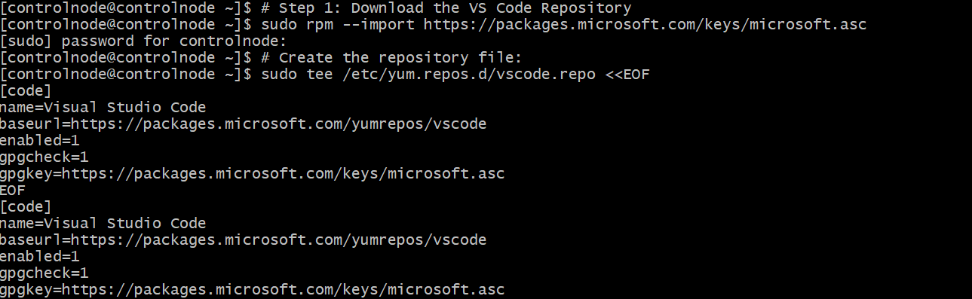

Step 2: Install VS Code
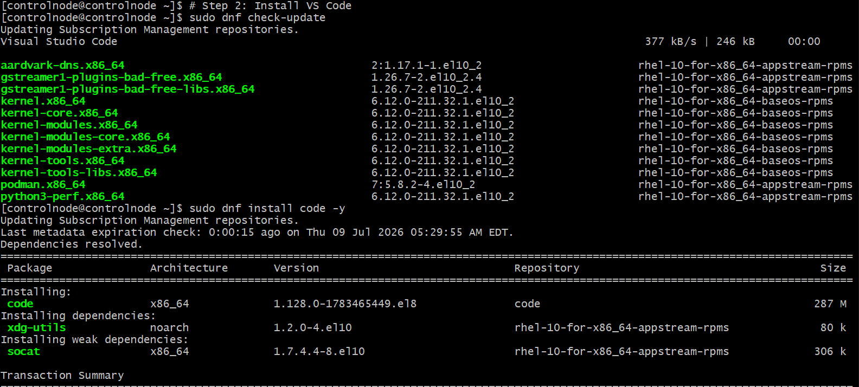

Step 3: Verify Installation



Step 4: Launch VS Code

Configure Ansible Navigator in the Terminal

Step 1: Check Python Version

Step 2: Install pip (if not already installed)

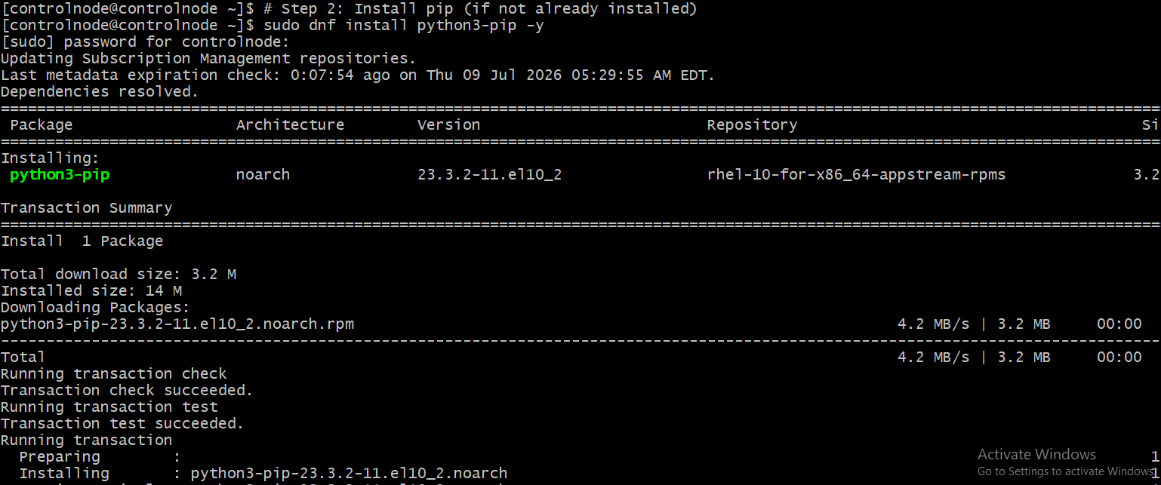

Step 3: Install Ansible Navigator

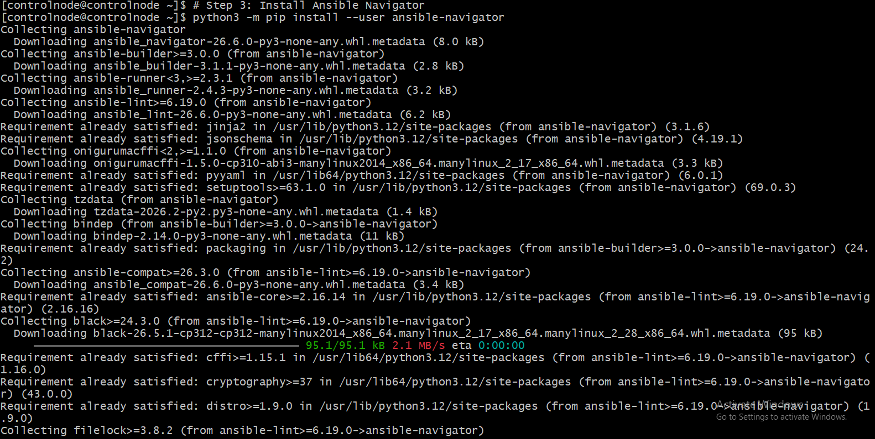

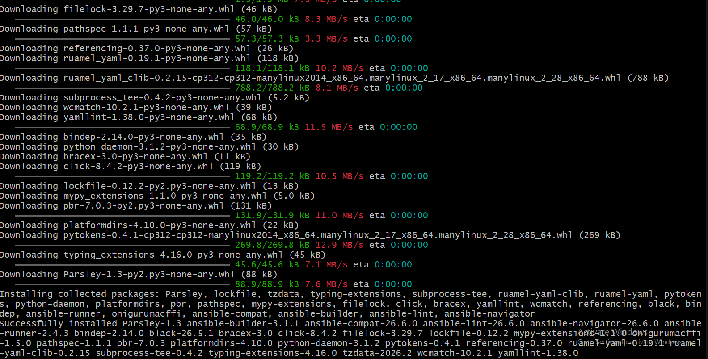

Step 4: Add the Local Binary Directory to PATH

Step 5: Verify Installation

Step 6: Display Help

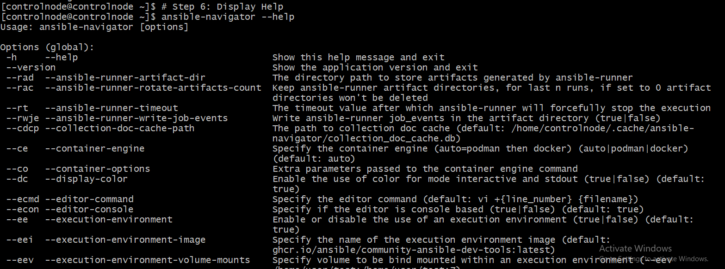

Configure Ansible Navigator in VS Code

Install Vs code in windows & open vs code



Step 2: Install the Ansible Extension

Open Visual Studio Code.
Click the Extensions icon (or press Ctrl + Shift + X).
Search for Ansible.
Install the Ansible extension published by Red Hat.

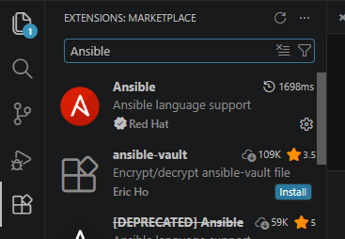

Step 3: Open Your Ansible Project

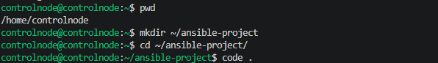

Step 4: Create an Ansible Configuration File

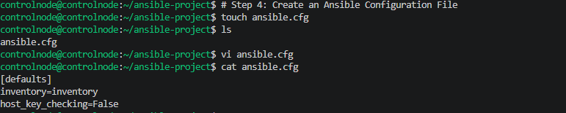

Add in ansible.cfg file
